Apprenticeship Training in Auto-CAD and the Development of Drafter Skills among Nigerian Workforce.

Theresa Patrick UDOMAH
Department of Industrial Technology Education
Faculty of Vocational Education, Library and Information Science
University Of Uyo, Uyo

Abstract
This study investigated the relationship between Apprenticeship Training in Auto-CAD and Development of Drafter Skills in workforce. In today’s entrepreneurial programme in University as a compulsory course for all the undergraduate and graduate students become questionable as to how many learners get understood of the trade under five to six weeks experience that could help the practice or make use of it after graduation. This is the problem of most Vocational Education Programmes. When there is no enough time put into practicing of a certain trade or course, it poses an issue of poor performance for job seekers, unemployment, chaos in the society, youth dependency, among others. As such the development of skills workforce becomes pandemic. If graduates of secondary and tertiary institutions after four or six year course work, enter into contractual apprenticeship training with the expert in the field, for instance autocad, the issue of job seeking would likely be alleviated, unemployment would be salvaged, graduates will be creative, innovative and self-employed. Therefore, it is recommended among other that university management should make it compulsory for graduate of both secondary and tertiary institution to embark on internship programme after their completion of coursework as this would help them fix well in the real world.

Keywords: Apprenticeship, Auto-CAD, Development, Drafter, Skills.

Introduction
AutoCAD is a software tool that facilitates the designing and communicating process, enabling users to create, modify, and model using a computer. Charter College (2019)AutoCAD is a computer-aided design software developed by the company. Autocad allows users to draw end edit digital 2D and 3D designs more quickly and easily than one could do by hand. This means that AutoCAD is an application designed to enhance quick and easy drawing and editing of any design, which could be used in industries such as engineering, construction, architecture and manufacturing, and interior design. AutoCAD enhance accuracy and faster production, timely delivery and maintaining optimum standard of the design. AutoCAD could be used across a variety of industries, such as in mechanical engineering, to create manufacturing processes as motor parts, design, robots and other innovative. In electrical engineering, AutoCAD is used to map out electrical systems, and in civil engineering is used to design bridges and roads, Olujimi (2024).
As an Architects, AutoCAD is often used to create blueprints and floor plans for houses and commercial buildings and also comes with built-in tools that can analyzed and remedy weaknesses in a building’s design Adekunbi (2024).
Then as a fine artist, the ability autoCAD are so wide-ranging that even artists use it to draft sculptures, wood carvings, engraving and experimental art pieces Friday, et al. (2017).
Before we go into the main AutoCAD application, we want to first of all consider relevant tools in AutoCAD 2D drawing.

Relevant Tools In AutoCAD 2d Drawing
- Line: to creates straight line segments
- Circle: to draw circles
- Arc: to creates arc
- Rectangle: to draw rectangles
- Polygon: to creates polygons
- Polyline: to connects drawing line segments and arcs
- Trim: Trim objects to meet specific boundaries
- Extend: Extend objects to meet specific boundaries
- Offset: to creates parallel copies of objects
- Mirror: to creates mirror copy
- Move: to relocates objects
- Copy: to duplicates objects
- Scale: to resizes objects
- Rotate: rotate objects
- Hatch: to fills enclosed area with problems
- Dimension: to add dimensions
- Text: to add text annotations
- Array: creates multiple copies of objects in pattern
- Stretch: stretches objects
- Break: breaks objects into two separate objects
- Join: Joins multiple objects into a single objects

1.1 Modifications Tools in AutoCAD
- Move: to relocates objects
- Copy: to duplicates objects
- Rotate: rotate objects
- Scale: to resizes objects
- Trim: trim objects to meet specific boundaries
- Mirror: creates mirror copies of objects
- Offset: to creates parallel copies of objects
- Extend: Extend objects to meet specific boundaries
- Array: creates multiple copies of objects in pattern
- Stretch: stretches objects
- Break: breaks objects into two separate objects
- Join: Joins multiple objects into a single objects

1.2 Drawing tools
- Line: creates straight line segments
- Circle: draw circles
- Arc: creates arc
- Rectangle: draw rectangles
- Polygon: create polygons
- Polyline: draws connected line segments and arcs
- Ellipse: draws ellipse
- Spline: creates smooth curves
- Point: creates point objects

General Mechanism in AutoCAD 2D Drawing
Boot your laptop, then launch into AutoCAD and create a new drawing
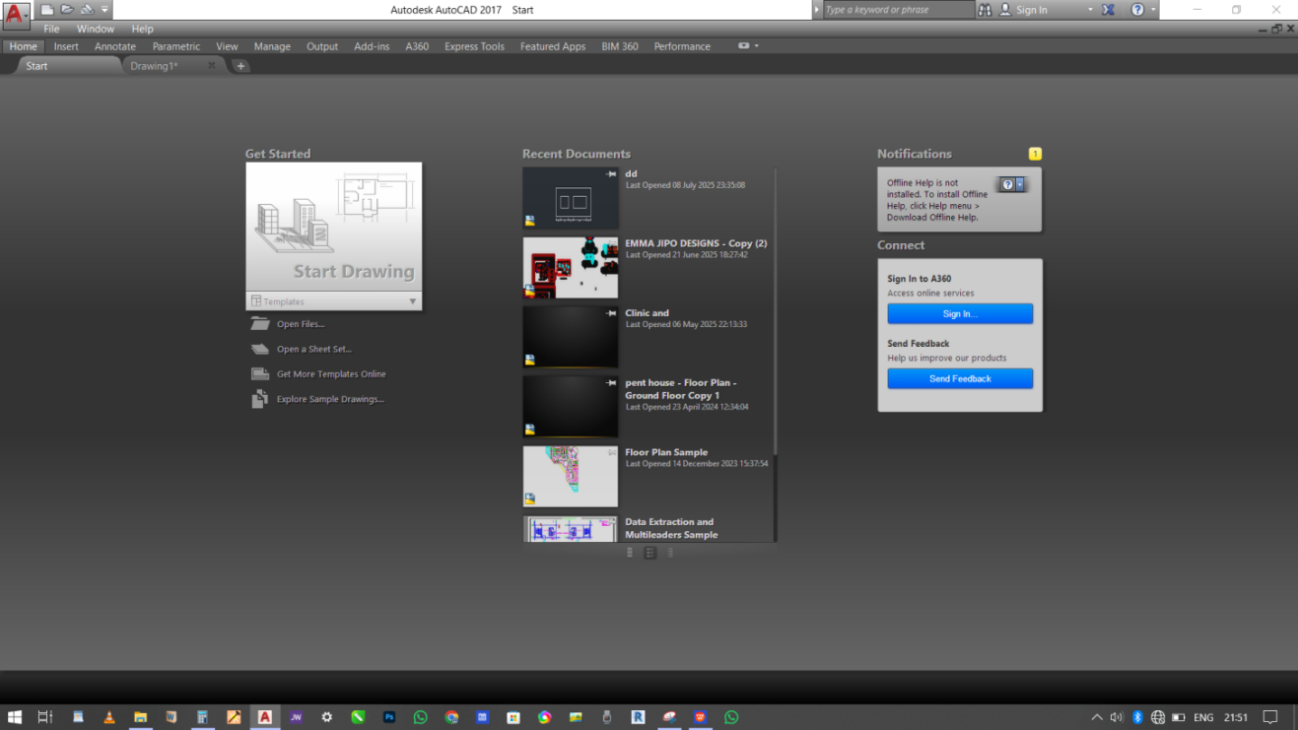
Figure 1: Start drawing
- Open autocad and left-click on New, to create new drawing file
- Used your keyboard to type a file name and press enter

Set up your drawing environment
- Left-click your mouse on the units bottom in the status bar or you type units in the command line down the system and press enter.
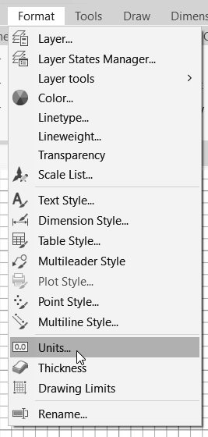

Figure 2: Status Bar
- Set your unit type and scale using the dialog box by right click with your mouse.
- 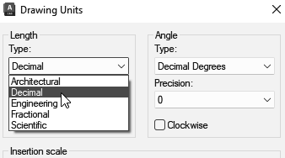
Figure 3; Drawing Units

To draw lines
- Left-click on the line tool in the drawing panel as type “L” in the command. Line down the system and press enter
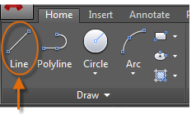
Figure 4: Draw line
- Left-click your mouse to specify the start-point and endpoint of the line
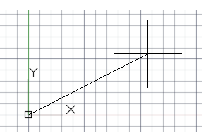
Figure 5: Startpoint and Endpoint of the line
- Press enter to end the line command
To draw circles
- Left circle with your mouse on the circle tools in the drawing panel or type ‘C’ in the command line and press enter
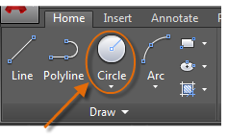
Figure 6: Drawing of circle
- Left-click with your mouse to specify the center point of the circle
- Type the radius value using few keyboard and press enter

To modify objects
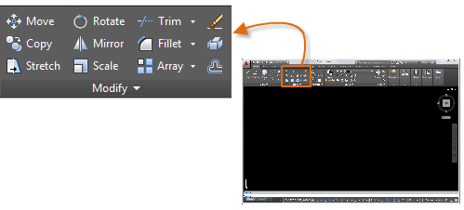
Figure 7: Modify Object
- Left-click with your mouse on the “move” tool in the modify panel or type ‘m’ in the command line and press enter
- Left-click with your mouse and select the object you want to move
- Left-click with mouse to specify the new location
- Press enter to complete the move command
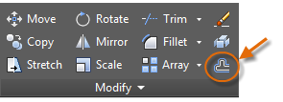
Figure 8: Offset
- Left-click on offset tool
- Choose object to offset
- Specify the offset distance
- Choose the size to offset

To Add dimensions
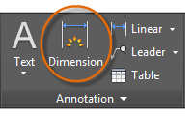
Figure 9: Add dimensions
- Left-click on the dimension tool in the annotate panel
- Left-click to select existing dimension
- Double left-click on dimension to access dimension properties or edit an existing dimension by using properties palette (Ctrl+1)

3.0 How These Tools are Used in Autocad 2DDrawing
3.1 Set up to drawing tools
- Use the unit command to set up the unit type and scale by left-click with your mouse or type unit in the keyboard
- Left-click with mouse the limit command to set the drawing area
3.2 In drawing basic shapes
- Left-click on line tool to draw straight lines
- Left-click with mouse to draw circles on circle tool
- Left-click with mouse to draw rectangles on rectangular tool
- Left-click with mouse on polygon tool to draw polygons

3.3 Modification of objects
- Left-click with mouse on move tool to relocate objects
- Left-click with mouse on copy tool to duplicate objects
- Left-click with mouse and rotate tool to rotate objects
- Left-click with mouse on scale to resize object

3.4 Addition of details
- Left-click on offset tool to create parallel copies of objects
- Left-click on trim tool to trim objects to meet specific boundaries
- Left-click on extend tool to extend objects
- Left-click on fillet tool to create rounded corners

3.5 Creation of complex shapes
- Left-click on polyline tool to draw connected line segments and arcs
- Left-click on spline tool to create smooth curves
- Left-click on ellipse tool to draw ellipses

Addition of Annotations
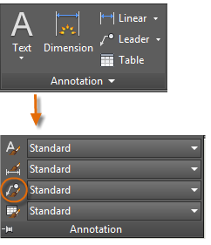
- Left-click on text tool to add text annotations

Figure 9: Addition of Annotations

- Left-click on dimension tool to add dimension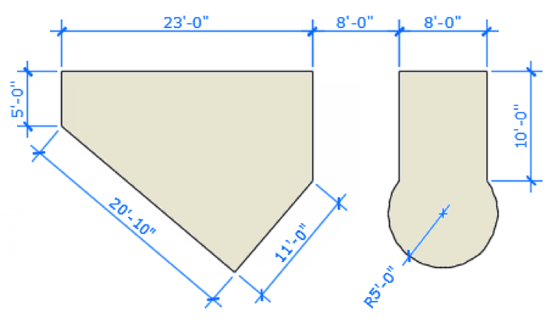s
Figure 10: Example of dimension
- Left-click on hatch tool to full enclosed areas with patterns
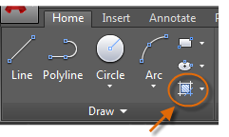
Figure 11: Finalizing the drawing

- Left-click on zoom and pan tools to navigate the drawing
- Left-click on save command to save the drawing file

Creating A 2D Floor Plan of A House in Autocad
4.1 Set up the drawing
- With mouse Left-click to open autoCAD application and create a new drawing file
- Left-click to set the units to a suitable scale for example meters or millimeters
- Left-click the drawing limit to match the size of your floor plan
Figure 12: Draw the outer walls
- Left-click on line tool to draw the outer walls of the house, measure 150mm dimensions of the floor plan, by typing on the keyboard then press enter to complete the command
- Left-click on line tool to draw again 3600mm dimension from the floor plan to the ceiling of the house by typing on the keyboard then press enter
- Specify the coordinates or use the mouse to draw the lines
- Always keep to ortho mode to ensure straight lines

Offset
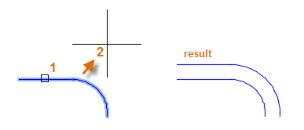
Figure 13: Offset
- Left-click to activate offset tool to create concentric parallel lines to draw the inner walls, or type offset in the command line and press enter
- Specify the offset distance, enter the offset distance value using your keyboard and press enter or specify the distance with your mouse with Left-click
- Left-click to select the object to be offset
- Left-click one offset side, where you want to create

4.2 Addition of Dimensions
- Left-click to create a new dimension on dimension tool in the annotate panel to add dimension to your floor plan
- Left-click to specify the style or format of dimensions or Left-click to select existing dimension on the dimension tool

4.3 Addition of Doors
- Left-click on thin line or line your choice to create a line of 900mm dimension
- Offset 100mm dimension on both sides to create the frame of the door to have a total of 200m
- Left-click on line tool to create 700mm dimension of the main door
- Left-click on arc tool to create an arc at a distance equal 900mm dimension or you type 900mm on the keyboard then press enter to create an equal dimension of the frame and the main door
- Fix your door and trim the excess line

4.4 Addition of windows
- Left-click on line tool to draw the window frame or type on the keyboard 1200mm dimension and press enter to complete few command
- Specify the with and the height of the window, by offset tools create an equal dimension of 3600mm dimension of the entire room into three equal parts
- Left-click on thick line tool to create three segmental lines with the choice colour, then fix your window

4.5 Use blocks or symbols for standard window and door designs
- Finalize your drawing by Left-click on zoom and pan tool to review the floor plan
- Make any necessary adjustment and save your drawing file

Conclusion
It was concluded based on the findings that apprenticeship training in auto-cad relates significantly to the development of drafter skill workforce among technical and vocational education graduate in Akwa Ibom State. The effective apprenticeship training in autocad enhances the development of drafter skill workforce among technical and vocational education graduates. The findings of this study would be of immense benefit in contribution to knowledge in the sense that, many researchers in different places and times have tried to solve the issues of development of drafter skill workforce, using different variables other than in relation to apprenticeship training in autocad, yet the issue seems to persist where this study is set to ameliorate the situation. This study has provided empirical evidence that would serve as a reference material to other researchers for further studies.

Recommendation
Based on the findings of the study, it was concluded that graduates of technical and vocational education should engage in apprenticeship training regardless of the years in university course work as this would help them to development skill workforce relevant in the society. Therefore, it is recommended among others that University management should make it compulsory for graduate of technical and vocational education to embark on internship programme after their completion of coursework as this would help them fix well in the real world

References
Adekunbi, S., Isiaka, M.A and Isiaka, R.K. (2024). A Qualitative Analysis of the State of Apprenticeship Training in Abeokuta South Local Government. Lapai Journal of Economics; 8, (1): 214-220.
Adeyeye, J. O., Falola, H.O. Waribo, J. Y. and Akinbode, J. O (2015). The Effects of Apprenticeship System on Skill Development of Employees in the Printing Industry in Lagos State, Nigeria. British Journal of Economics, Finance and Management Sciences, 10 (2): 16-30.
Akande, B. S. (2015). Apprenticeship Training in Nigeria: A Neglected Variable in Nation Building.
Charter College (2019). Who Uses AutoCAD and Why Is It Important? last updated 12/31/19.
Friday, A.J, Ikpe, U.G and Imoh-Ita, U.P. (2024). Leaders’ emotional intelligent characteristics: a panacea for educational transformation and national development in Nigeria. Education, Sustainability & Society (ESS) 7(2): 53-57.
Louisiana Workforce commission (2017). Civil Drafter. U.S. Department of Labor Bureau of Labor Statistics.
Olujimi, V. A (2024). Indigenous Man-Power Training and Apprenticeship as A Strategy for Youth Empowerment in Oyo State, South West, Nigeria. International Journal of Research and Innovation in Social Science.

